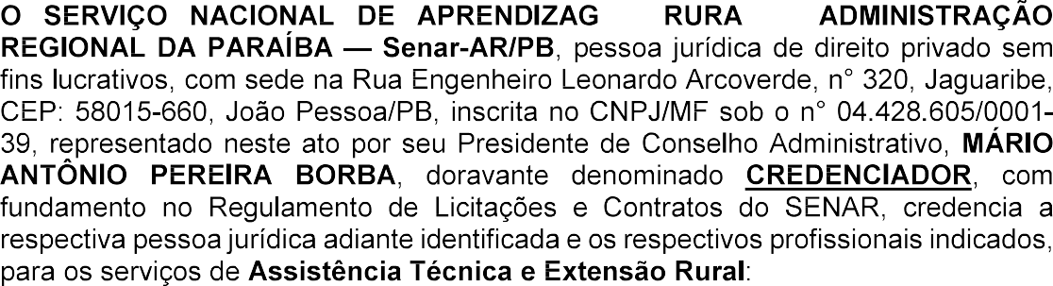

__________________________________________________________________________________________________________________________________________________________________________________________________________________________________________________________________________________________________________________________________________________________________________________________________________________________________________________________________________________________________________________________________________________________________________________________________________________________________________________
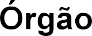



João Pessoa/PB, _____de __________________de ________.

<<Representante Legal (NOME COMPLETO)>>
<<Razão Social>> Credenciado

- __________________
- __________________
- __________________
- __________________

